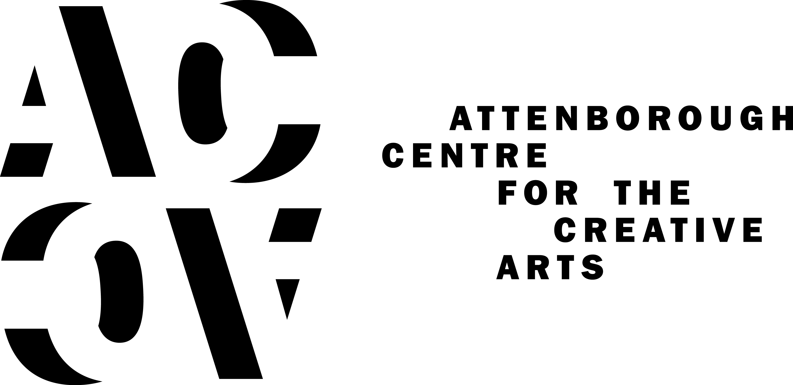

BRYONY KIMMINGS’ CRITICALLY ACCLAIMED I’M A PHOENIX, BITCH HEADLINES BRIGHTON FRINGE 2019 LAUNCH WEEKEND

Artist, theatre-maker, comedian, musician and activist, Bryony Kimmings brings I’m a Phoenix, Bitch to Brighton’s Attenborough Centre for the Creative Arts, from 3-7 May 2019 - a headline performance of the opening weekend of Brighton Fringe 2019. Following huge critical acclaim during its opening run in London, the Brighton dates will be the first for the show outside the capital. This will also be the first time that Attenborough Centre for the Creative Arts has been a host venue for Brighton Fringe.
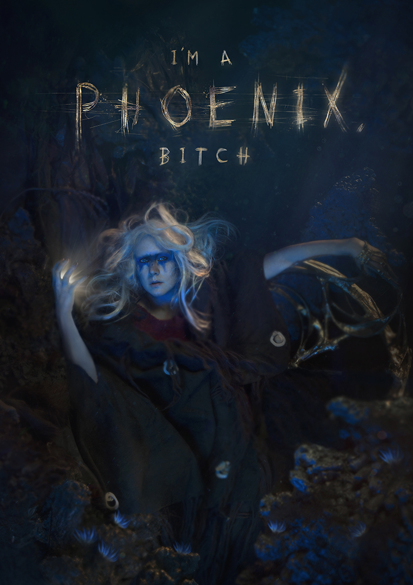
I’m a Phoenix, Bitch has been co-commissioned by Attenborough Centre for the Creative Arts, Battersea Arts Centre and Arts Centre Melbourne and was partially created during a residency at ACCA in summer 2018.

Combining personal stories with epic film, soundscapes and ethereal music, Bryony creates a powerful, dark and joyful work about motherhood, heartbreak and finding inner strength. A mythical legend performed straight from a heart still pulsing with pain. Ever sunk so deep you felt like you might never make it up for air?

In 2016, Bryony nearly drowned. Postnatal breakdowns, an imploding relationship and an extremely sick child left her sitting beneath the waves hoping she could slowly turn to shell.

Two years later and she is able to deal with life again, but wears the scars of that year like a dark and heavy cloak. Who do we become after trauma? How do we turn pain into power? How do we fly instead of drown?

We will need new myths to survive the end of existence as we know it. In this show a new legend will be created; that of the invincible and fearless woman; a tale Bryony wishes she had known from birth.
Bryony Kimmings says, “My shows are usually born out of me going: ‘We don’t talk about this enough, this is problematic in terms of a political or feminist narrative.’ My hope with this show is to give the almost unspeakable traumas associated with postnatal depression and an ill child a voice. I wanted to create a show that cuts to the heart of these things but does it in a way that people can relate to.”

★★★★★
What's On Stage

★★★★★
“Bryony Kimmings’ deeply personal show is an exhilarating ride via pop video, horror movie, art installation and therapy session...a double inspiration and a testimony both to human resilience and the healing properties of art”
The Guardian

★★★★
“Imagine a metaphysical glitter cannon of trauma being fired straight at your chest”
TimeOut

★★★★
The Stage

ENDS

For press information: nicola@attenboroughcentre.com / info@attenboroughcentre.com / 01273 678 822

LISTINGS INFORMATION:

I’m a Phoenix, Bitch at Attenborough Centre for the Creative Arts
Title: I’m a Phoenix, Bitch
Artist/Company: Bryony Kimmings
Venue: Attenborough Centre for the Creative Arts, University of Sussex, Gardner Centre Road, Brighton, East Sussex, BN1 9RA
Date: 3 – 7 May 2019. BSL and captioned performance Sunday 5 May 4pm.
Time: 8pm (4pm matinees on Sunday 5 & Monday 6 May)
Price: £16 - £18 (£12 - £14 concessions)
(Pay What You Decide tickets are also available)
Booking Link: www.attenboroughcentre.com
Box Office: 01273 678 822 (open 10am-4pm Monday to Friday)

Notes to Editors:
I’m a Phoenix, Bitch is financially supported by Arts Council England, commissioned by Battersea Arts Centre, Arts Centre Melbourne and Attenborough Centre for the Creative Arts and supported by Latitude Festival and in association with Avalon Promotions.
In 2016 Bryony nearly drowned. Postnatal breakdowns, an imploding relationship and a very sick child left her sitting beneath the waves hoping she could slowly turn to shell. When Battersea Arts Centre invited her to create a new work for the previously burnt down Grand Hall, she felt an affinity with that building, for her own life had also burnt to the ground that year.
Bryony Kimmings
Bryony Kimmings is renowned for her outlandish “social experiments” with previous works seeing her retrace an STI to its source, spending seven days in a controlled environment in a constant state of intoxication and becoming a pop star invented by a nine-year-old girl.
Her most recent work A Pacifists Guide to the War on Cancer was commissioned by Complicite and presented at The Royal National Theatre and HOME, Manchester. The touring version of this show was performed at venues across England and in Melbourne and Sydney. Bryony’s award winning work has toured internationally including: Antifest (Finland), Culturgest (Portugal), Fusebox Festival (Texas), Southbank Centre (London), Seymour Centre, Melbourne International Comedy Festival (Australia) and Lisinski Operahouse (Croatia).
Attenborough Centre for the Creative Arts
Attenborough Centre for the Creative Arts is a cultural hub located on the University of Sussex campus. The centre brings the university, local residents and the wider national and international arts communities together through its multi-disciplinary programme of music, film, dance, installation, performance, discussion and debate.

The building is a Grade II* listed building designed by Sir Basil Spence and originally opened in 1969. The fully refurbished space contains a flexible 350-seat auditorium, studios for teaching/research/rehearsal, café/bar and social meeting area.

Attenborough Centre for the Creative Arts is named after Richard Attenborough (former Chancellor at University of Sussex). The programme at the centre is guided by Lord Attenborough's values: human rights, social justice, creative education and access to the arts for all.

Attenborough Centre for the Creative Arts is led by Creative Director Laura McDermott and is part of the University of Sussex.

Join our conversation:
Facebook: Attenborough Centre for Creative Arts
Twitter: attenboroughctr
Instagram: attenboroughctr
www.attenboroughcentre.com

